Employee Management System

* Introduction

An Employee Management System (EMS) is a digital solution designed to help organizations manage their workforce efficiently. It streamlines a variety of HR functions, including employee data management, attendance tracking, payroll processing, performance evaluation, and recruitment. By centralizing these tasks, an EMS reduces administrative workload, enhances accuracy, and fosters better decision-making within an organization. The system also improves communication between HR and employees, offering self-service options for tasks like leave requests and updating personal information. In essence, EMS helps companies optimize their workforce management, leading to improved productivity and operational efficiency.

* Existing App

In the domain of Employee Management Systems (EMS), various apps and software solutions have emerged, each offering a range of features designed to optimize HR processes. Here’s a brief survey of some notable existing apps:

1. **BambooHR:**

* **Focus:** Small and medium-sized businesses.
* **Key Features:** Employee data management, onboarding, performance management, time-off tracking, and reporting.
* **Strength:** User-friendly interface and easy customization.
* **Limitation:** Limited payroll functionality in some countries.

1. **Zoho People:**

* **Focus:** All business sizes.

• **KeyFeatures:** Attendance management, leave tracking, employee database, performance reviews,

and self-service portal.

* **Strength:** Integrates with other Zoho products,

offering a comprehensive business suite.

* **Limitation:** Some advanced features require a higher pricing tier.

1. **Gusto:**

• **Focus:** Small businesses, primarily in the US.

• **Key Features:** Payroll, benefits, time tracking, and

compliance management.

• **Strength:** Easy payroll processing and employee

benefits administration.

• **Limitation:** Mainly focused on US-based companies.

1. **Workday:**

• **Focus:** Large enterprises.

• **Key Features:** Human capital management,

financial management, and payroll.

• **Strength:** Highly scalable and suitable for global organizations.

• **Limitation:** Expensive and complex, with a steep learning curve.

* **Database Tables:**

**User Information**

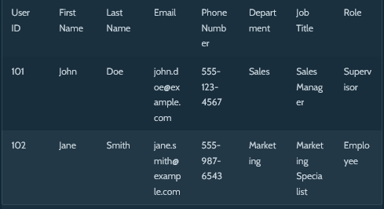

**Employee Performance**

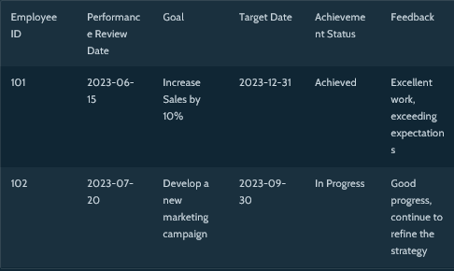

**Time Off Requests**

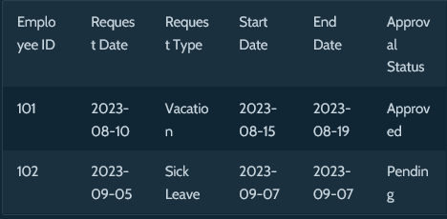

* WorkFlow Diagram:

